Assignment(29-12-2023)

Azure Databricks Components Creation in Azure DataBricksAccount

**Workspace:**WorkSpace is an environment where we can access all the databricks assests.

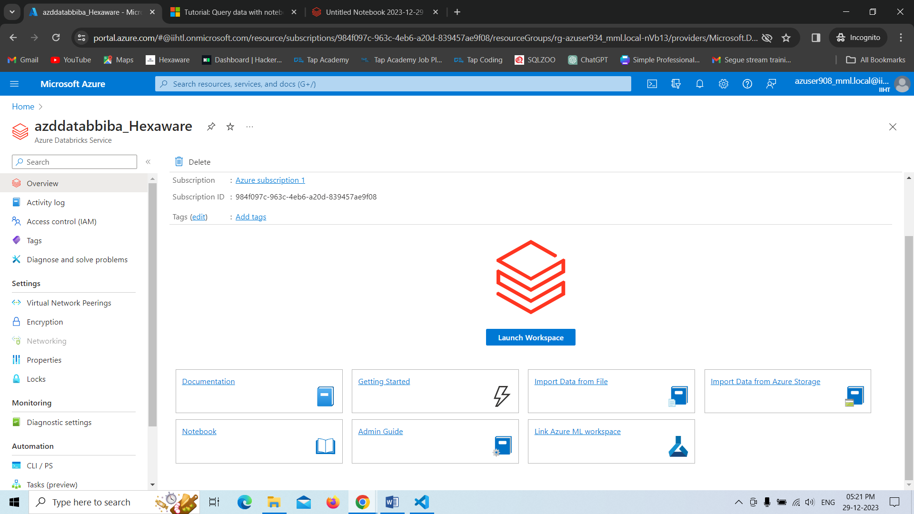

**Cluster:**It is a collection of Databricks Computation Resources.

**Creating a cluster.**

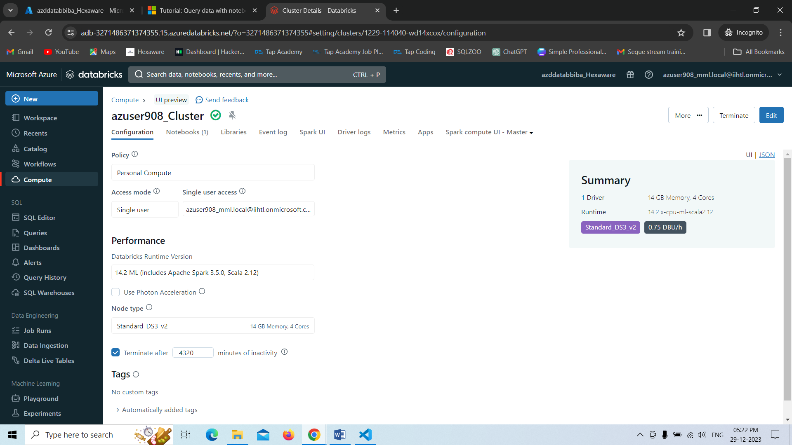

**Notebook:** Notebook is a combination of cells that contain certain script in order to execute.

**Creating a Notebook:**

* Here we have created a notebook and run demo script in the cell of that notebook.
* In order to execute the things in notebook we need to attach that notebook to a cluster at that time only the note book will run and gives us output.

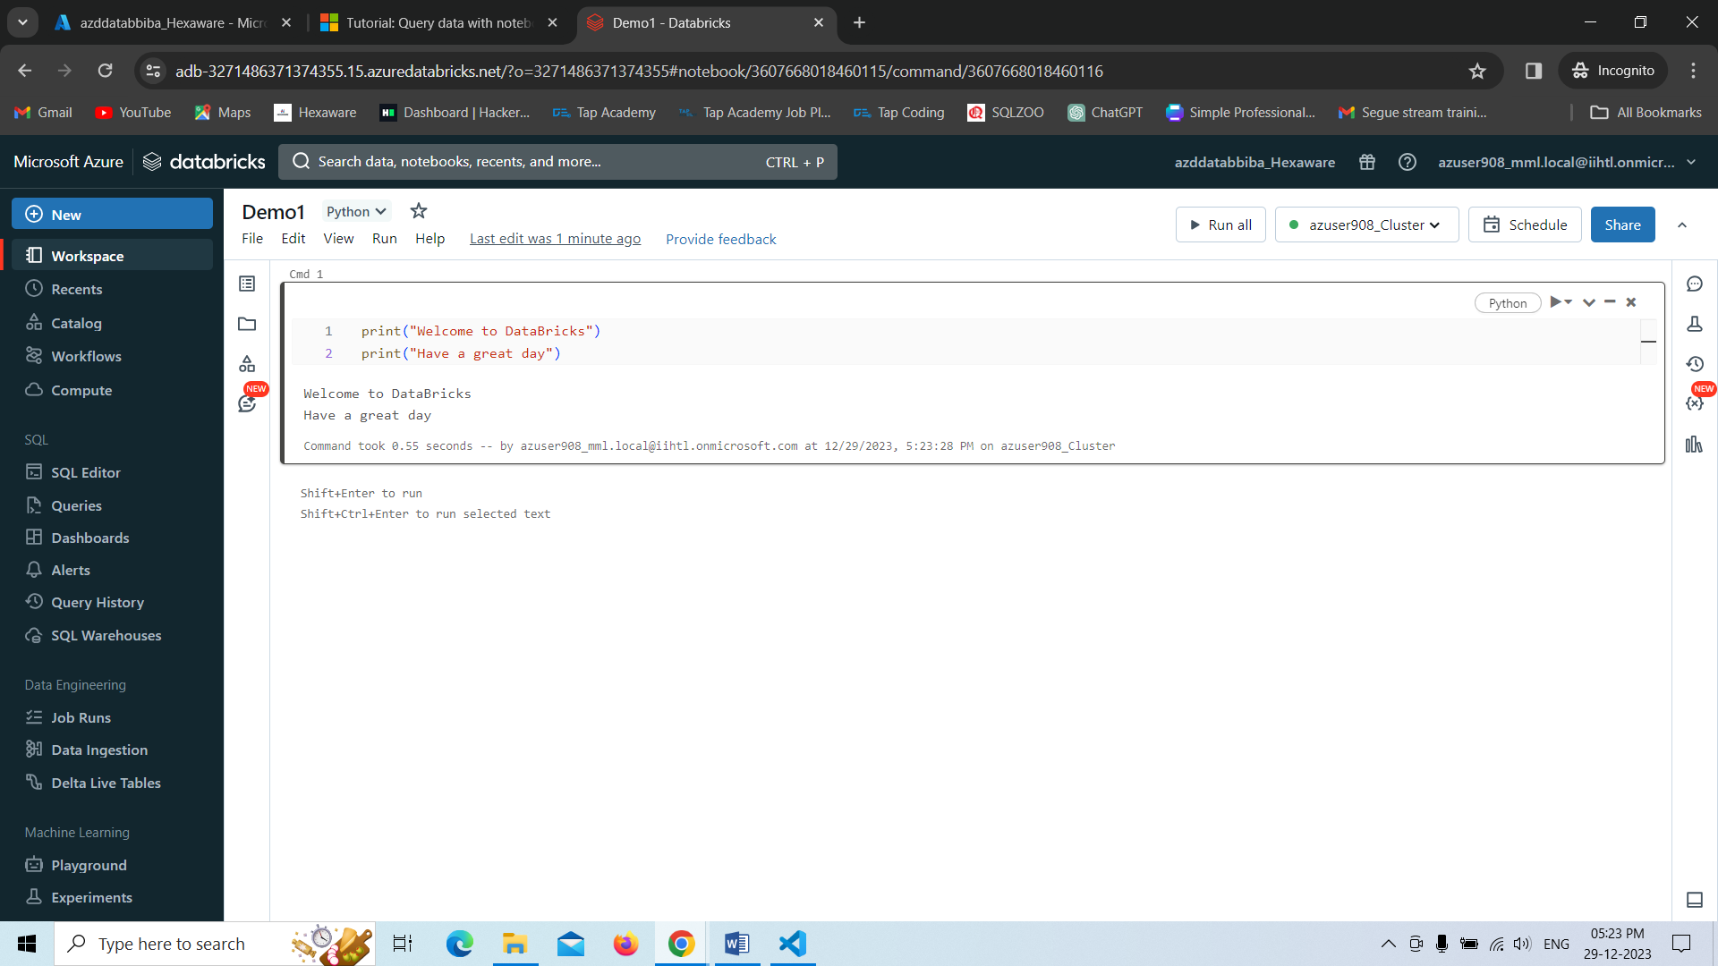

**Program 2-**Here we are using distinct filter in order to display unique salaries from each department with pyspark.

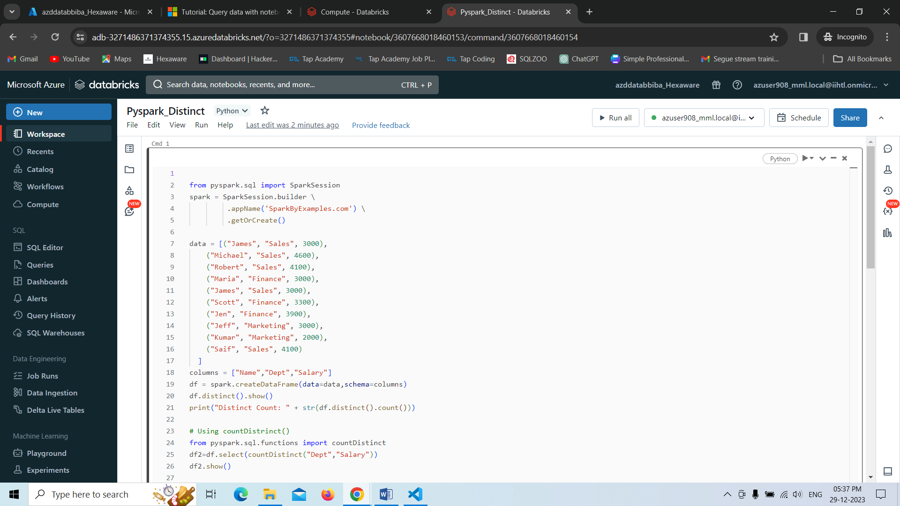

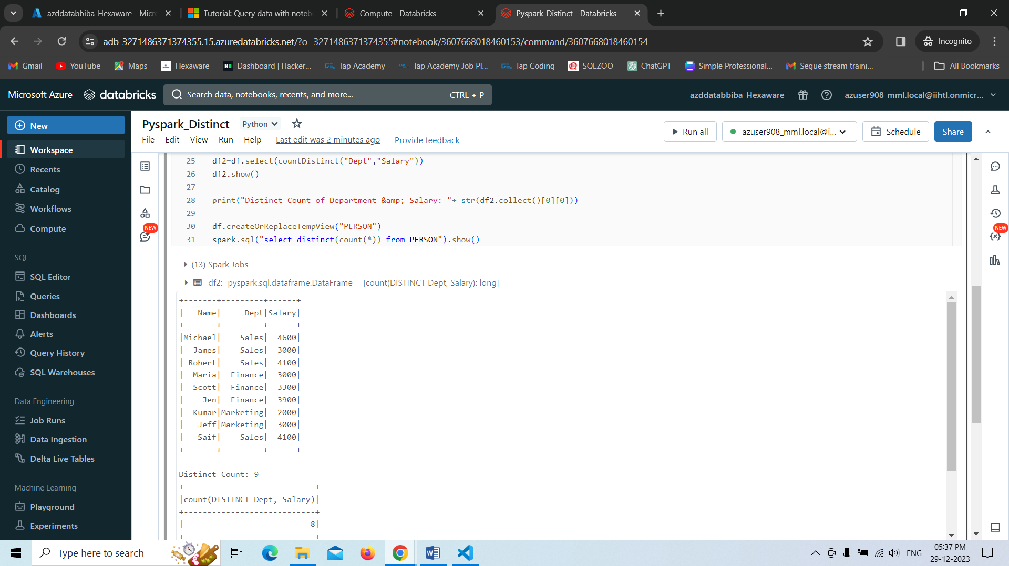

**Program 3-**

In this program,we are creating a list in the pyspark environment with the help of sparkSession ,finally we are displaying the data by converting into it.

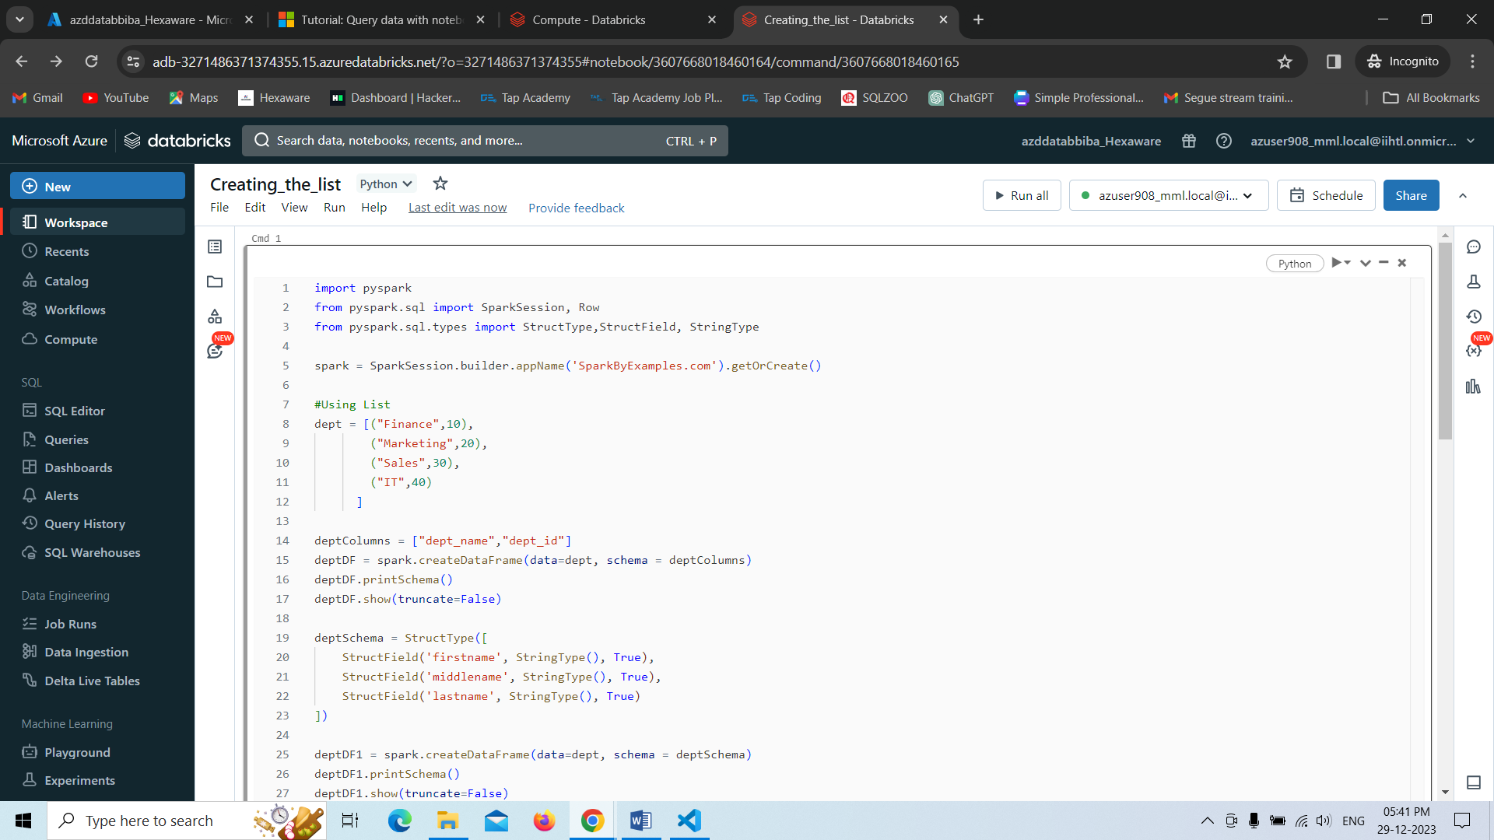

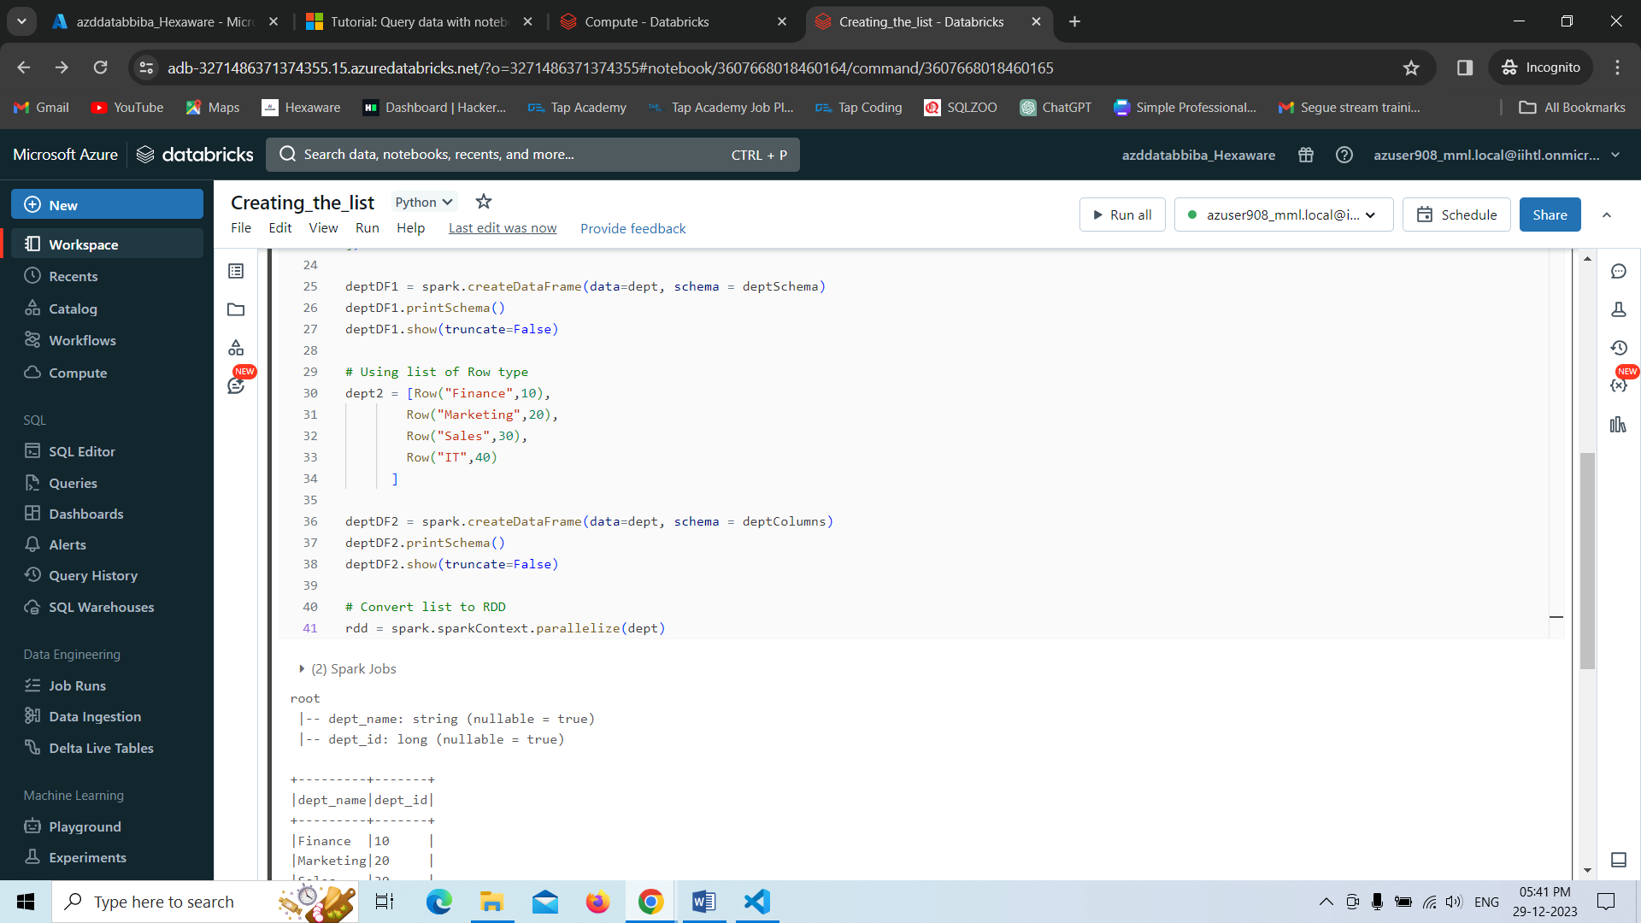

**Program 4-**

In this program we are displaying the currentdate as according to the user desired format.

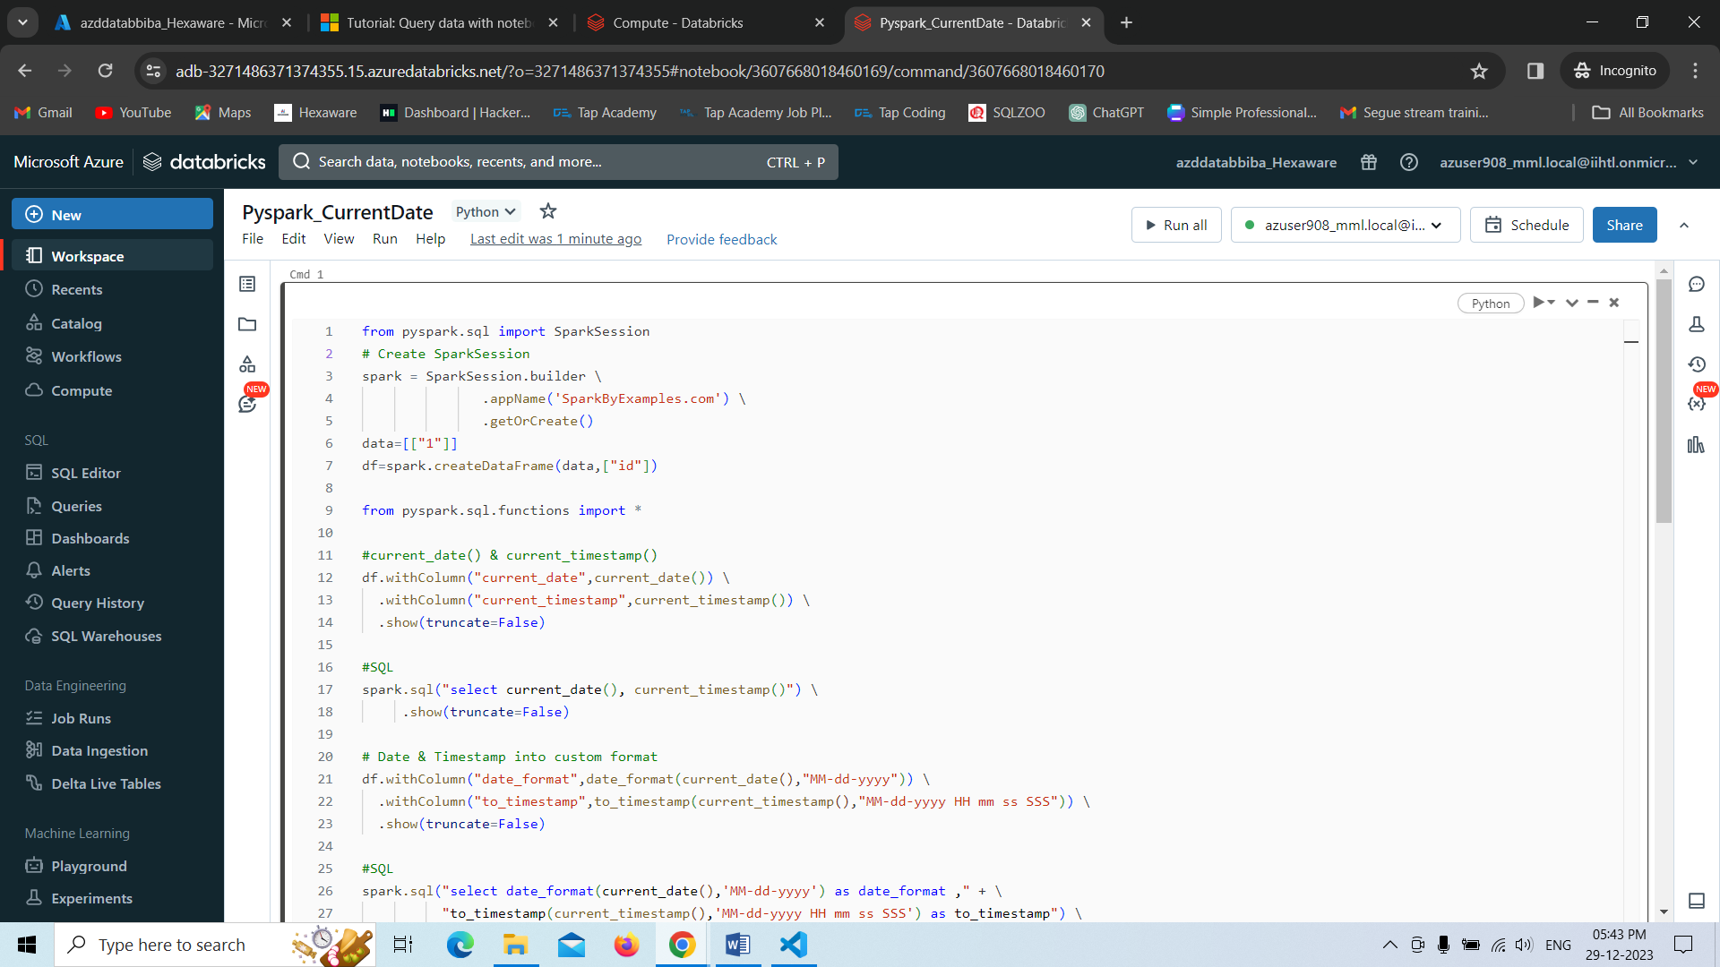

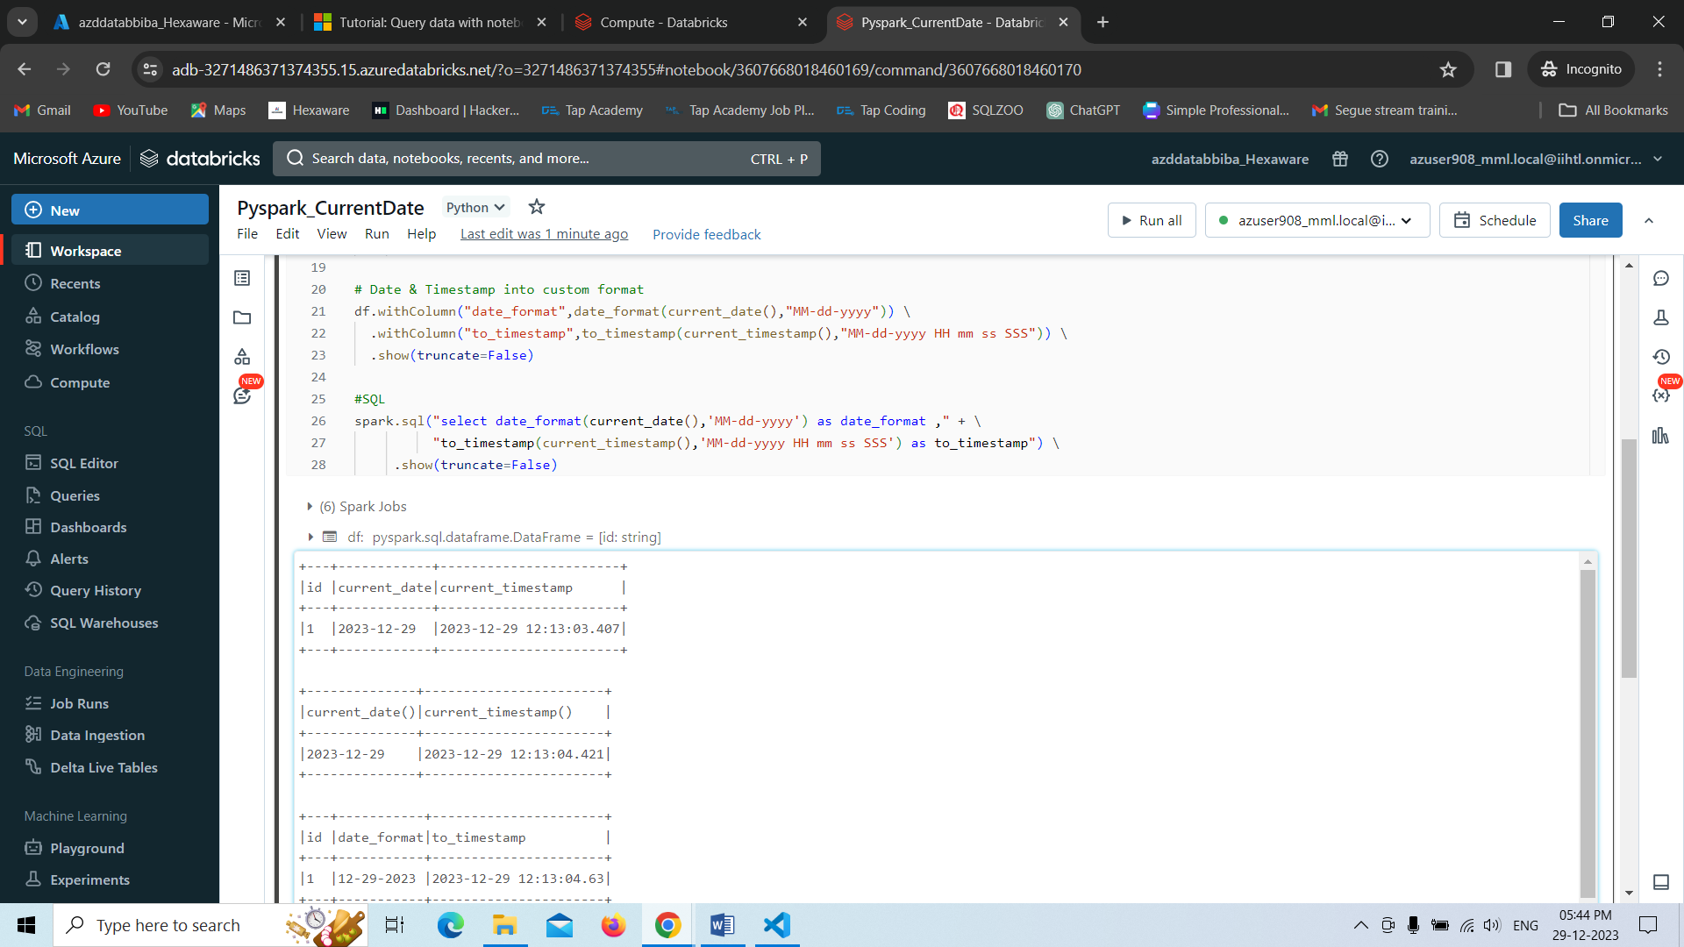

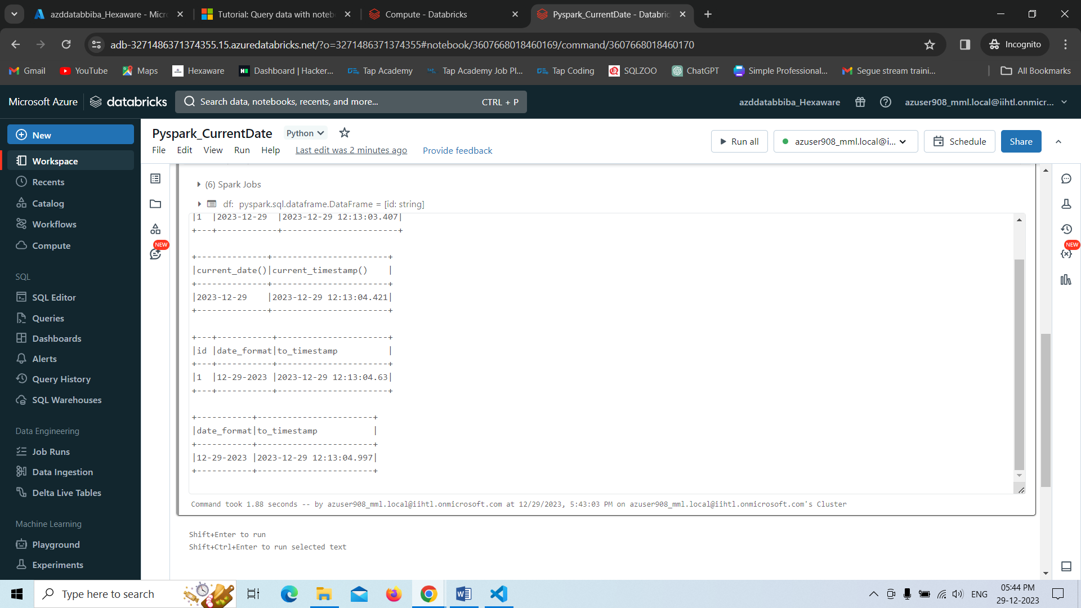

**Program 5-**

In this program, we are creating the dataframe and just displaying the result as it has been created.

